Documentation Deliverable

It covers the documentation that you have developed in association with your project.

User Manual

{Marking Requirement:

The guide for the end user of your project

It indicates which functions are available to the user.

The functions should be explained in detail such that after reading the manual the user would have a good idea how to interact with your application.

(Excellent, well-written user manual is succinct but covers all functionality available in your application. Extended tasks are documented as tutorials, and features documented as reference documentation.)}

Install the Customer Product Transparency mobile application into your mobile. The detail installation instruction refers to CPT installation guide.

Features

1. Scanning the barcode of product
2. Getting the scanned product information
3. Tracking the product manufacturing location
4. Commenting and rating the scanned product
5. Seeing the recent scanned product
6. Mange the favorite scanned product
7. Setting

1. Scanning the barcode of product

1.1 Press the camera button to start scanning.

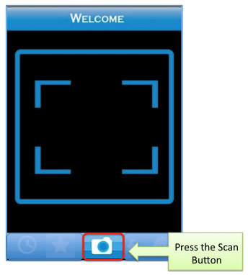

1.2 Point the scanner at the bar code on the product.

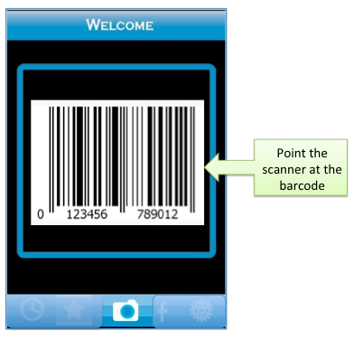

1.3 Hold the mobile and make sure that the red line across the barcode.

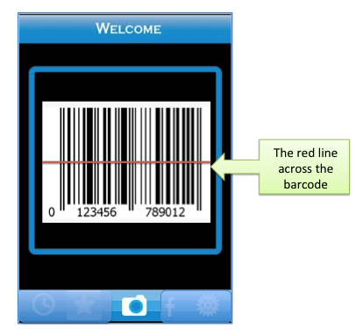

1.4 The scanning process is finished after a flashing on the screen.

2. Getting the scanned product information.

2.1 After scanning the product successfully, the product information page should appear

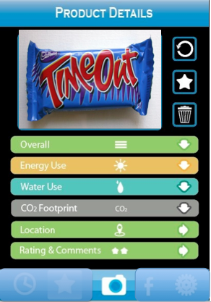

2.2 Press the information title to see full details for the scanned product

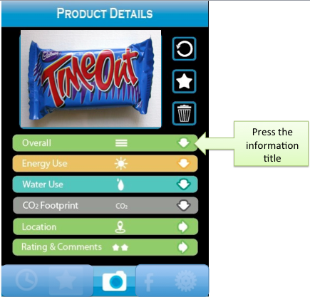

3. Tracking the product manufacturing location

3.1 On the product information page press the ‘Location’ button to track the product location

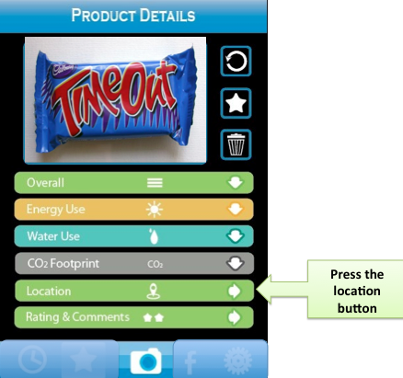

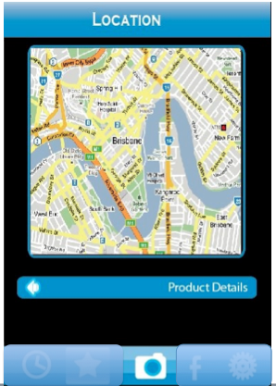

3.2 Press ‘Product Details’ to go back to product information page

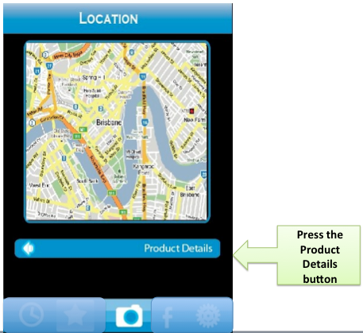

4. Commenting and rating the scanned product

4.1 Before commenting and rating the product, you are required to login to the Facebook.

There are two ways to login to the Facebook.

4.1.1 Login to Facebook by press the ‘Facebook’ button

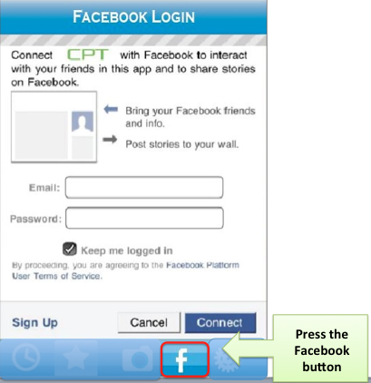

4.1.2 Login to the Facebook by press the ‘Rating & Comments’ button

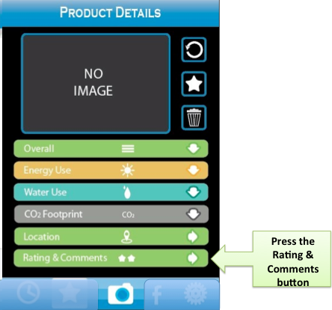

4.2 Press the star symbol to rate and write the comments in the text box, and then press ‘Confirm’ to submit your comments

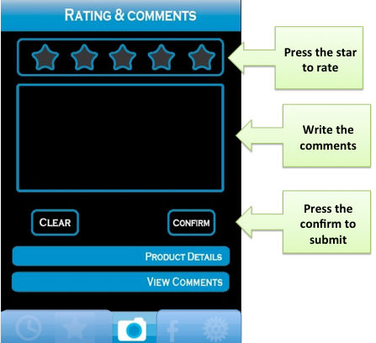

4.3 Press the ‘Product Details’ to go to product information page and ‘View comments’ to see other comments regarding to the scanned product

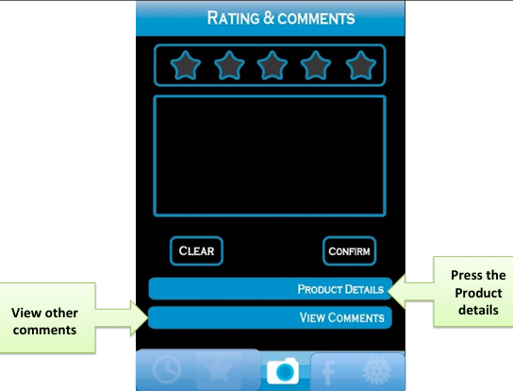

5. Seeing the recent scanned product

5.1 Press the history button to see recent scanned product

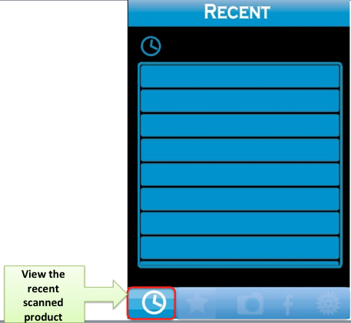

5.2 Press and hold the product name, the message box should pop up, you can either delete the product or add to favourite from recent page.

6. Mange the favorite scanned product

6.1 Seeing and delete the favourite product

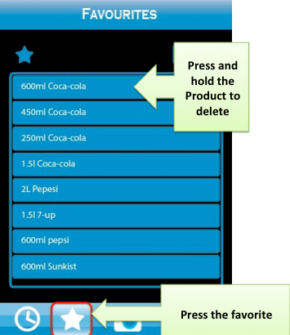

6.2 Add product to the favourite list

6.2.1 On the ‘Recent’ product page, press and hold the product name, the message box should pop up, you can add to favourite from recent page.

6.2.2 On the scanned information page, press the star to add the scanned product to favourite list.

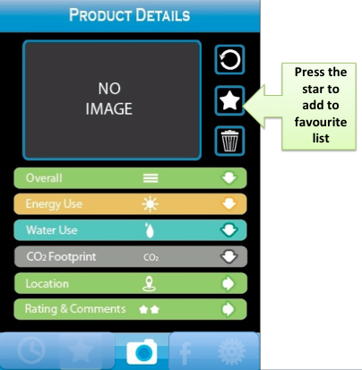

7. Setting

a. Press the setting button on the menu bar

b. Choose the type of barcode to scan

c. Choose the sound or vibert when barcode is found

d. Turn on/Off the front light when scanning

Checking the location of the product production or manufacturer

Checking the information of the product

User guide for the website

1. Add new product

There are two ways to add a new product:

When people flag a product that is not yet in the data base

Or you can type in all the information required into the table of “Manage Product” and update.

Deployment/Installation Manual

A guide for how your project will be setup in the target environment.

It should give explicit requirements and instruction for the user to understand the installation and maintenance of the project. (Comprehensive installation and deployment documentation provides everything an administrator might need to deploy his or her own copy of your software. Any prerequisites are well described, and the installation procedure is broken down into simple-to-follow steps that include any necessary details. )

Frequently Asked Questions (FAQs)

A summary of questions and answers regarding your project that have arisen during development and testing

These should answer any questions that a naïve user may have with the project even possibly after reading the user manual and/or deployment/installation manual.

Test Plan and Test Results

An important aspect of your project

As with the test plan and test results from the first semester design phase, it is important that you stringently test your work so that you can be confident your functionality is stable and correct and so that you can be sure your user interfaces make sense to users who are not their designers.

Again, as per the test plan and test results from the first semester, design phase, this test plan and test results consists of the following parts:

a. Functional Testing is the blow-by-blow testing of functionality: Do your inputs and outputs act as expected, and how well does your application handle errors?

b. User Testing covers the aspects of your application that functional testing cannot. That is: Does your application make sense? Can naive users accomplish what they need to using your application with-out outside intervention?

For both of these sections, you should deliver both a plan and a summary of your results.

(Complete and excellent test coverage of your application: Functional tests (unit tests and integration tests) cover your application significantly. User testing and test results with final interface are demonstrated to have helped you to polish your final inter-face to a very high level. )

Other consists of any other material that is not listed above. Such examples of this would be advertising material (posters, videos, television/internet advertisements), App Store or Market-place pages etc. Discuss these options with your tutor.

(You have created polished release material highly relevant to your application: App store pages, packaging/posters, or a brochure website. )